Lab - 6

Hello World of Machine Learning
The best small project to start with on a new tool is the classification of iris flowers (e.g. the iris dataset).

- Attributes are numeric so you have to figure out how to load and handle data.
- It is a classification problem, allowing you to practice with perhaps an easier type of supervised learning algorithm.
- It is a multi-class classification problem (multi-nominal) that may require some specialized handling.
- It only has 4 attributes and 150 rows, meaning it is small and easily fits into memory (and a screen or A4 page).
- All of the numeric attributes are in the same units and the same scale, not requiring any special scaling or transforms to get started.

To do
- Installing the Python and SciPy platform.
- Loading the dataset.
- Summarizing the dataset.
- Dimensions of the dataset.
- Peek at the data itself.
- Statistical summary of all attributes.
- Breakdown of the data by the class variable.

- Visualizing the dataset.
- Univariate plots to better understand each attribute.
- Multivariate plots to better understand the relationships between attributes.

- Evaluating some algorithms.
- Separate out a validation dataset.
- Set-up the test harness to use 10-fold cross validation.
- Build multiple different models to predict species from flower measurements
- Select the best model.
test 6 different algorithms:
- Logistic Regression (LR)
- Linear Discriminant Analysis (LDA)
- K-Nearest Neighbors (KNN).
- Classification and Regression Trees (CART).
- Gaussian Naive Bayes (NB).
- Support Vector Machines (SVM).

- Making some predictions.
##Install The Dataset
pip install ucimlrepo
##Import the dataset
from ucimlrepo import fetch_ucirepo
#Import Iris dataset from the datasets
iris = fetch_ucirepo(id=53)
#3. Summarizing The dataset
##Dimention of the dataset
df = iris.data.original
print(df.shape)
(150, 5)
##Peek the data itself
print(df.head())
sepal length sepal width petal length petal width class
0 5.1 3.5 1.4 0.2 Iris-setosa
1 4.9 3.0 1.4 0.2 Iris-setosa
2 4.7 3.2 1.3 0.2 Iris-setosa
3 4.6 3.1 1.5 0.2 Iris-setosa
4 5.0 3.6 1.4 0.2 Iris-setosa
##Statistical Summary of the attributes
print(df.describe())
sepal length sepal width petal length petal width
count 150.000000 150.000000 150.000000 150.000000
mean 5.843333 3.054000 3.758667 1.198667
std 0.828066 0.433594 1.764420 0.763161
min 4.300000 2.000000 1.000000 0.100000
25% 5.100000 2.800000 1.600000 0.300000
50% 5.800000 3.000000 4.350000 1.300000
75% 6.400000 3.300000 5.100000 1.800000
max 7.900000 4.400000 6.900000 2.500000

##Breakdown the data by class veriables
print(df['class'].value_counts())
class
Iris-setosa 50
Iris-versicolor 50
Iris-virginica 50
Name: count, dtype: int64
##4. Visualizing the dataset.
#Univariate plots
numeric_data = df.drop(columns=['class'])
#Box plot
numeric_data.plot(kind='box', subplots=True, sharex=False, sharey=False)
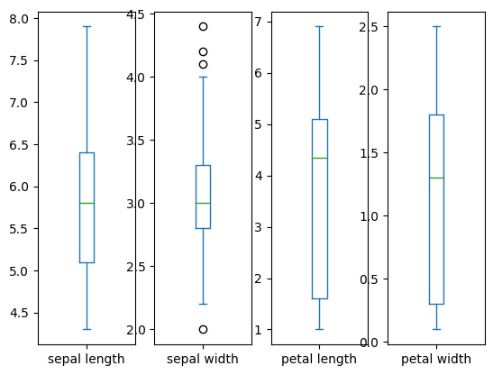
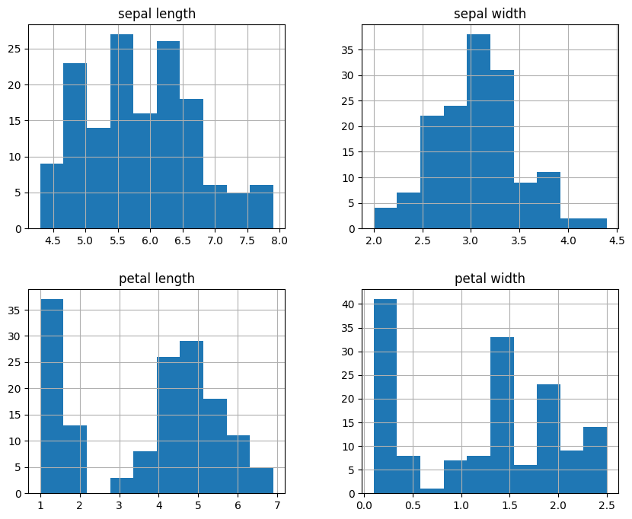
sepal length Axes(0.125,0.11;0.168478x0.77)
sepal width Axes(0.327174,0.11;0.168478x0.77)
petal length Axes(0.529348,0.11;0.168478x0.77)
petal width Axes(0.731522,0.11;0.168478x0.77)
dtype: object

# Histogram
numeric_data.hist(figsize=(10, 8))
array([[<Axes: title={'center': 'sepal length'}>,
<Axes: title={'center': 'sepal width'}>],
[<Axes: title={'center': 'petal length'}>,
<Axes: title={'center': 'petal width'}>]], dtype=object)

# Multivariate plots
from pandas.plotting import scatter_matrix
scatter_matrix(df, figsize=(10, 10), diagonal='kde')
array([[<Axes: xlabel='sepal length', ylabel='sepal length'>,
<Axes: xlabel='sepal width', ylabel='sepal length'>,
<Axes: xlabel='petal length', ylabel='sepal length'>,
<Axes: xlabel='petal width', ylabel='sepal length'>],
[<Axes: xlabel='sepal length', ylabel='sepal width'>,
<Axes: xlabel='sepal width', ylabel='sepal width'>,
<Axes: xlabel='petal length', ylabel='sepal width'>,
<Axes: xlabel='petal width', ylabel='sepal width'>],
[<Axes: xlabel='sepal length', ylabel='petal length'>,
<Axes: xlabel='sepal width', ylabel='petal length'>,
<Axes: xlabel='petal length', ylabel='petal length'>,
<Axes: xlabel='petal width', ylabel='petal length'>],
[<Axes: xlabel='sepal length', ylabel='petal width'>,
<Axes: xlabel='sepal width', ylabel='petal width'>,
<Axes: xlabel='petal length', ylabel='petal width'>,
<Axes: xlabel='petal width', ylabel='petal width'>]], dtype=object)
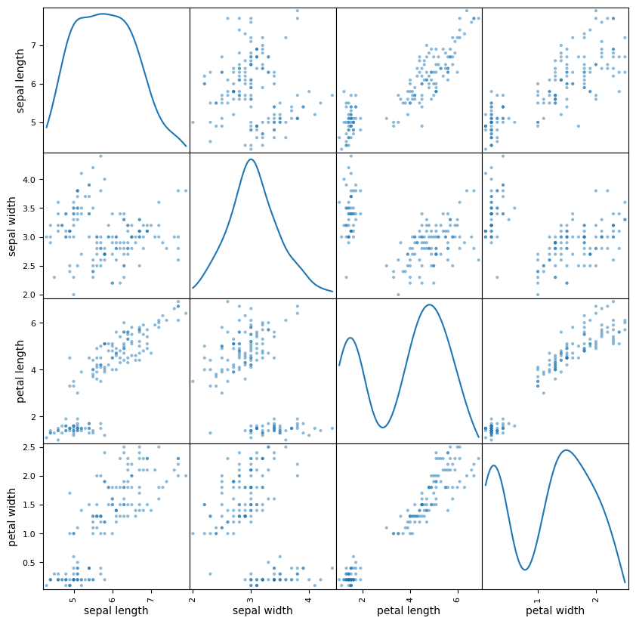
##Prepare model
from sklearn.model_selection import train_test_split, KFold
x = df.iloc[:,:-1]
y = df['class']
x_train, x_validation, y_train, y_validation = train_test_split(x, y, test_size = 0.2, random_state = 1)
kfold = KFold(n_splits=10, random_state=1, shuffle=True)
##5. Evaluate Algorithms
models = []
from sklearn.linear_model import LogisticRegression
models.append(("Logistic Regression(LR)", LogisticRegression(max_iter=200)))
from sklearn.discriminant_analysis import LinearDiscriminantAnalysis
models.append(('Linear Discriminant Analysis(LDA)', LinearDiscriminantAnalysis()))
from sklearn.neighbors import KNeighborsClassifier
models.append(('K-Nearest Neighbors(KNN)', KNeighborsClassifier()))
from sklearn.tree import DecisionTreeClassifier
models.append(('Classification and Redression Trees (CART)', DecisionTreeClassifier()))
from sklearn.naive_bayes import GaussianNB
models.append(('Gaussian Naive Bayes(NB)', GaussianNB()))
from sklearn.svm import SVC
models.append(('Support Vector Machines(SVM)', SVC()))
from sklearn.model_selection import cross_val_score
for name, model in models:
model_result = cross_val_score(model, x_train, y_train, cv = kfold, scoring = 'accuracy')
print(f"{name} : {model_result.mean():.4f} ({model_result.std():.4f})")
Logistic Regression(LR) : 0.9667 (0.0408)
Linear Discriminant Analysis(LDA) : 0.9750 (0.0382)
K-Nearest Neighbors(KNN) : 0.9583 (0.0417)
Classification and Redression Trees (CART) : 0.9667 (0.0408)
Gaussian Naive Bayes(NB) : 0.9500 (0.0408)
Support Vector Machines(SVM) : 0.9667 (0.0408)

#6. Making some Predictions
#We choose the best model from the above tests
from sklearn.metrics import accuracy_score, confusion_matrix, classification_report
best_model = SVC()
best_model.fit(x_train, y_train)
predictions = best_model.predict(x_validation)
print(f"Accuracy: {accuracy_score(y_validation, predictions)}")
print(f"Confusion Matrix: \n{confusion_matrix(y_validation, predictions)}")
print(f"Classification Report: \n{classification_report(y_validation, predictions)}")
Accuracy: 0.9666666666666667
Confusion Matrix:
[[11 0 0]
[ 0 12 1]
[ 0 0 6]]
Classification Report:
precision recall f1-score support
Iris-setosa 1.00 1.00 1.00 11
Iris-versicolor 1.00 0.92 0.96 13
Iris-virginica 0.86 1.00 0.92 6
accuracy 0.97 30
macro avg 0.95 0.97 0.96 30
weighted avg 0.97 0.97 0.97 30

